Euler Line

Definition
# Source: AI Source: Provided by: [Data Path: Persons Table -> ID Column: 1, Name_En Column: Motasem Essam] -> From: [ChatGPT] on [7/25/2026]
The Euler Line is a line that contains several important centers of a triangle. In a general non-equilateral triangle, it passes through the:
- Circumcenter $O$
- Centroid $G$
- Orthocenter $H$
Thus:
$$\boxed{O, G, H\text{ are collinear}}$$
The Euler line is named after the Swiss mathematician Leonhard Euler, who studied this important relationship among triangle centers.
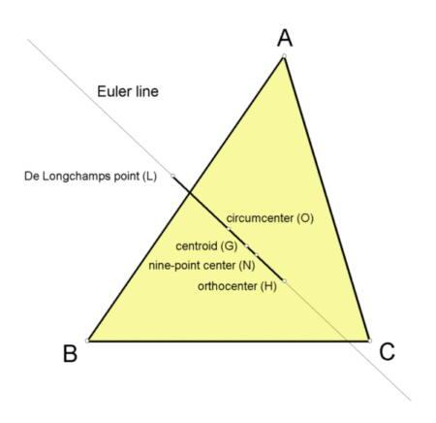
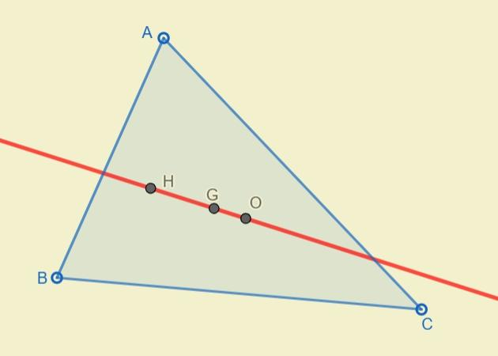
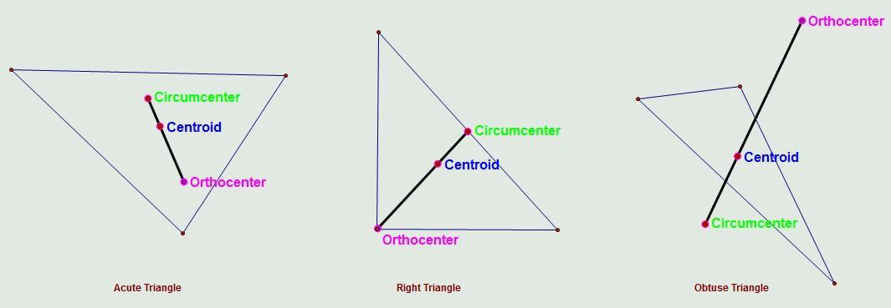
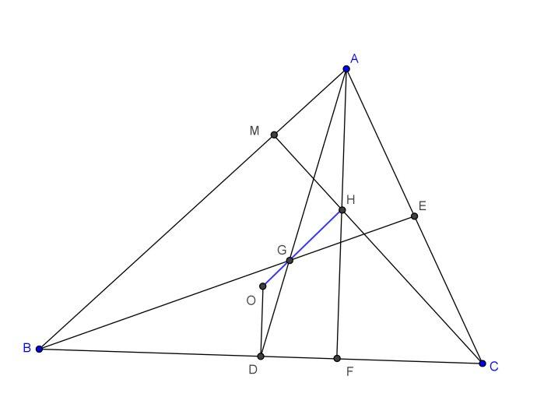
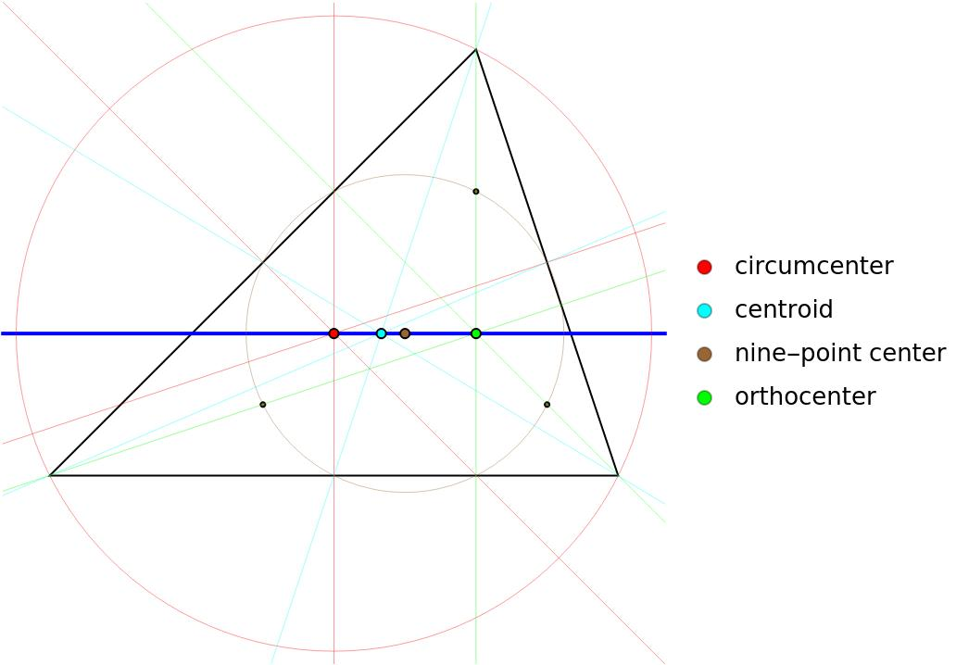

Purpose
# Source: AI Source: Provided by: [Data Path: Persons Table -> ID Column: 1, Name_En Column: Motasem Essam] -> From: [ChatGPT] on [7/25/2026]
The Euler line is used to:
- Show the relationship between major triangle centers.
- Establish a collinearity relationship between $O$, $G$, and $H$.
- Determine the relative positions of the circumcenter, centroid, and orthocenter.
- Derive important distance relationships between triangle centers.
- Study special cases such as equilateral and isosceles triangles.
- Analyze triangle geometry using coordinates and vectors.

Fundamental Elements
# Source: AI Source: Provided by: [Data Path: Persons Table -> ID Column: 1, Name_En Column: Motasem Essam] -> From: [ChatGPT] on [7/25/2026]
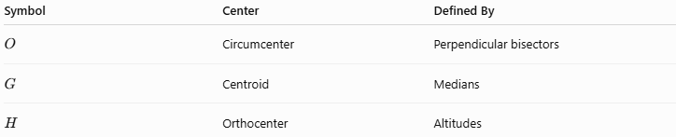
Symbol | Center | Defined By
$$O$$ | Circumcenter | Perpendicular bisectors
$$G$$ | Centroid | Medians
$$H$$ | Orthocenter | Altitudes
The fundamental Euler-line relationship is:
$$\boxed{O-G-H}$$
meaning that the three points lie on one straight line.

Euler Line Theorem
# Source: AI Source: Provided by: [Data Path: Persons Table -> ID Column: 1, Name_En Column: Motasem Essam] -> From: [ChatGPT] on [7/25/2026]
For a non-equilateral triangle:
$$\boxed{O, G, H\text{ are collinear}}$$
Therefore, the circumcenter, centroid, and orthocenter all lie on the same line.
This line is called the Euler line.
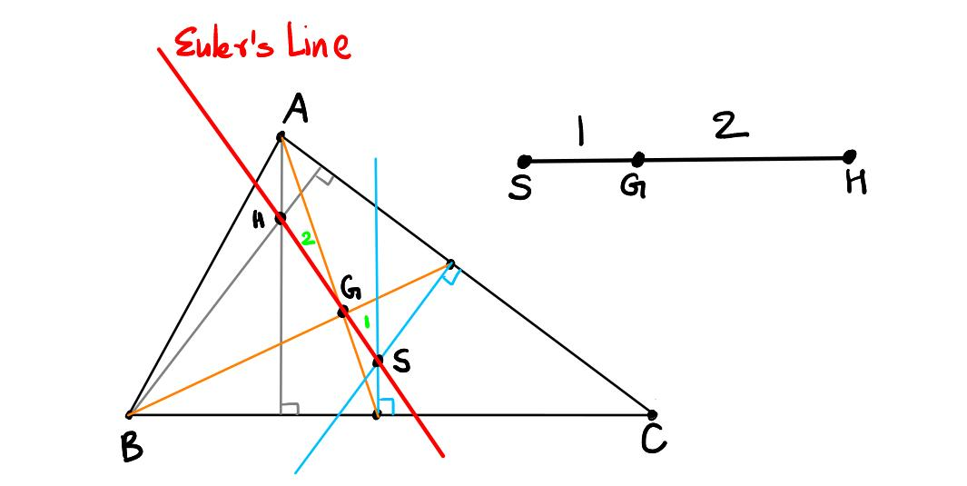
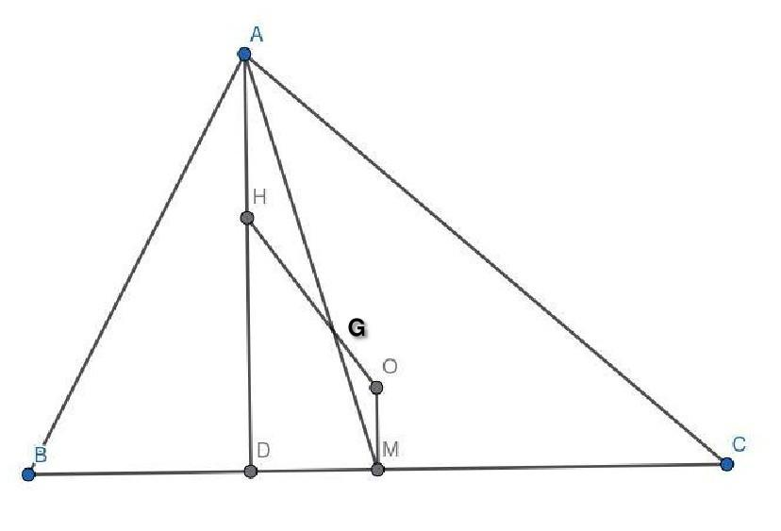
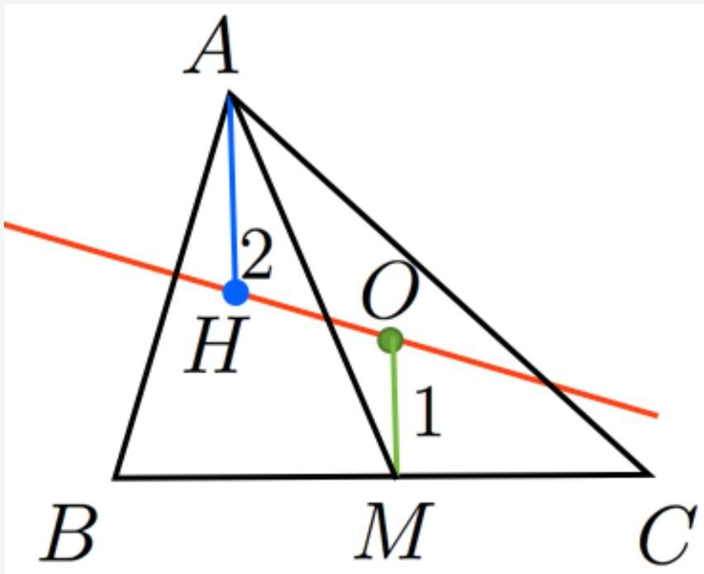

The $1:2$Ratio
# Source: AI Source: Provided by: [Data Path: Persons Table -> ID Column: 1, Name_En Column: Motasem Essam] -> From: [ChatGPT] on [7/25/2026]
One of the most important properties of the Euler line is the relationship between the three centers.
The centroid $G$divides the segment joining the circumcenter $O$and orthocenter $H$in the ratio:
$$\boxed{OG:GH=1:2}$$
Therefore:
$$\boxed{GH=2OG}$$
and:
$$\boxed{OH=3OG}$$
Equivalently:
$$\boxed{OG=\frac{1}{3}OH}$$
and:
$$\boxed{GH=\frac{2}{3}OH}$$
Thus, the centroid lies one-third of the way from the circumcenter to the orthocenter.

Vector Relationship
# Source: AI Source: Provided by: [Data Path: Persons Table -> ID Column: 1, Name_En Column: Motasem Essam] -> From: [ChatGPT] on [7/25/2026]
The Euler-line relationship can be expressed using position vectors.
If $O$, $G$, and $H$are represented by their position vectors, then:
$$\boxed{\vec{OH}=3\vec{OG}}$$
Equivalently:
$$\boxed{\vec{OG}=\frac{1}{3}\vec{OH}}$$
This directly shows that $O$, $G$, and $H$are collinear.

Coordinate Representation
# Source: AI Source: Provided by: [Data Path: Persons Table -> ID Column: 1, Name_En Column: Motasem Essam] -> From: [ChatGPT] on [7/25/2026]
Suppose the vertices of a triangle are:
$$A=\left(x_{1} , y_{1}\right) \\ B=\left(x_{2} , y_{2}\right) \\ C=\left(x_{3} , y_{3}\right)$$
The centroid is:
$$\boxed{G=\left(\frac{x_{1}+x_{2}+x_{3}}{3} , \frac{y_{1}+y_{2}+y_{3}}{3}\right)}$$
If the circumcenter $O$is known, the orthocenter can be obtained from the Euler-line relationship:
$$\boxed{H=3G-2O}$$
In coordinate form:
$$\boxed{H=\left(3 , x_{G}-2x_{O} 3y_{G}-2y_{O}\right)}$$
This is a useful way to find the orthocenter without calculating all three altitudes.

Example
# Source: AI Source: Provided by: [Data Path: Persons Table -> ID Column: 1, Name_En Column: Motasem Essam] -> From: [ChatGPT] on [7/25/2026]
Suppose:
$$O=\left(2 , 3\right)$$
and:
$$G=\left(4 , 5\right)$$
Using:
$$H=3G-2O$$
we get:
$$H=3\left(4 , 5\right)-2\left(2 , 3\right) \\ H=\left(12 , 15\right)-\left(4 , 6\right)$$
Therefore:
$$\boxed{H=\left(8 , 9\right)}$$
So the three centers are:
$$O=\left(2 , 3\right) \\ G=\left(4 , 5\right) \\ H=\left(8 , 9\right)$$
and they lie on the same straight line.

Euler Line and Triangle Type

Scalene Triangle
# Source: AI Source: Provided by: [Data Path: Persons Table -> ID Column: 1, Name_En Column: Motasem Essam] -> From: [ChatGPT] on [7/25/2026]
For a general scalene triangle, the three centers are usually distinct:
$$\boxed{O≠G≠H}$$
and they form a definite Euler line.
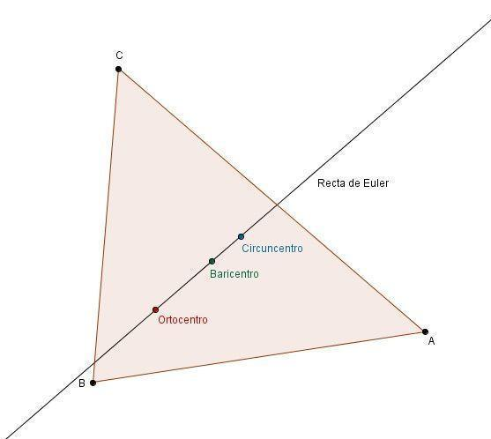

Isosceles Triangle
# Source: AI Source: Provided by: [Data Path: Persons Table -> ID Column: 1, Name_En Column: Motasem Essam] -> From: [ChatGPT] on [7/25/2026]
In an isosceles triangle, the Euler line lies along the triangle's axis of symmetry.
The circumcenter, centroid, and orthocenter all lie on this symmetry axis.
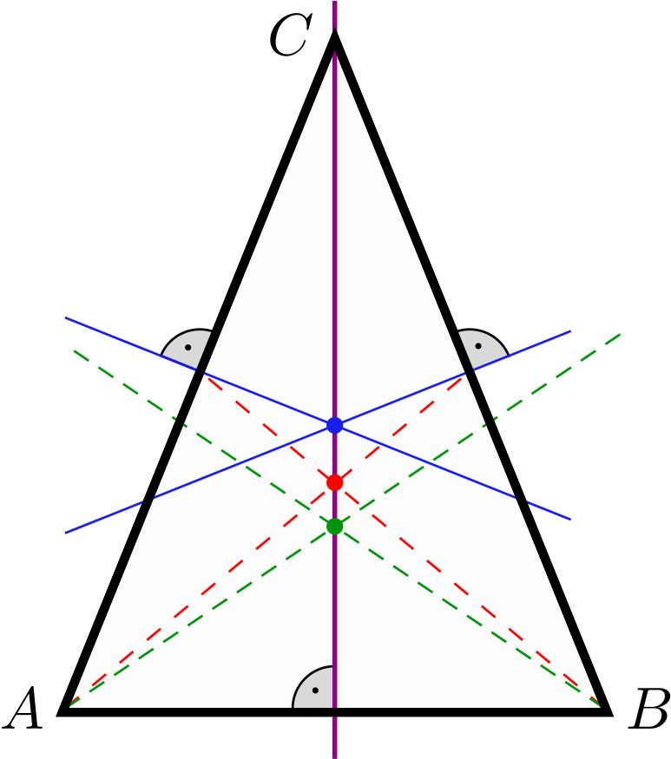
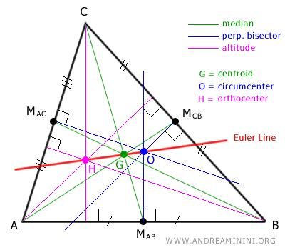
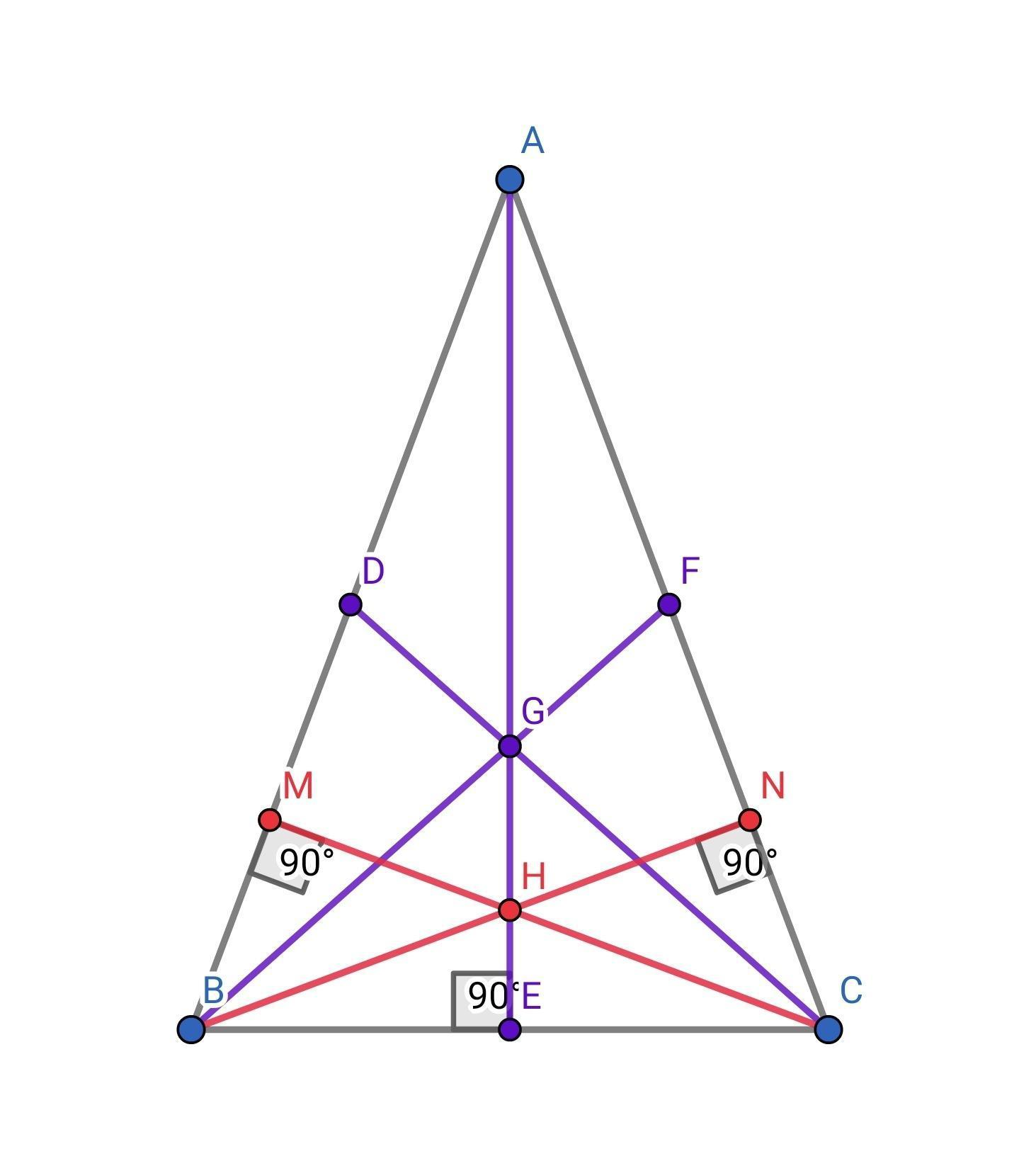

Equilateral Triangle
# Source: AI Source: Provided by: [Data Path: Persons Table -> ID Column: 1, Name_En Column: Motasem Essam] -> From: [ChatGPT] on [7/25/2026]
The equilateral triangle is a special case.
For an equilateral triangle:
$$\boxed{O=G=H}$$
The incenter also coincides with them:
$$\boxed{O=G=H=I}$$
Therefore, there is no unique Euler line in the usual sense because all the relevant centers are the same point.

Euler Line and the Four Principal Triangle Centers
# Source: AI Source: Provided by: [Data Path: Persons Table -> ID Column: 1, Name_En Column: Motasem Essam] -> From: [ChatGPT] on [7/25/2026]
The four classical triangle centers are:
- Centroid $G$
- Incenter $I$
- Circumcenter $O$
- Orthocenter $H$
Of these, the Euler line always contains:
$$\boxed{O, G, H}$$
The incenter $I$is generally not on the Euler line.
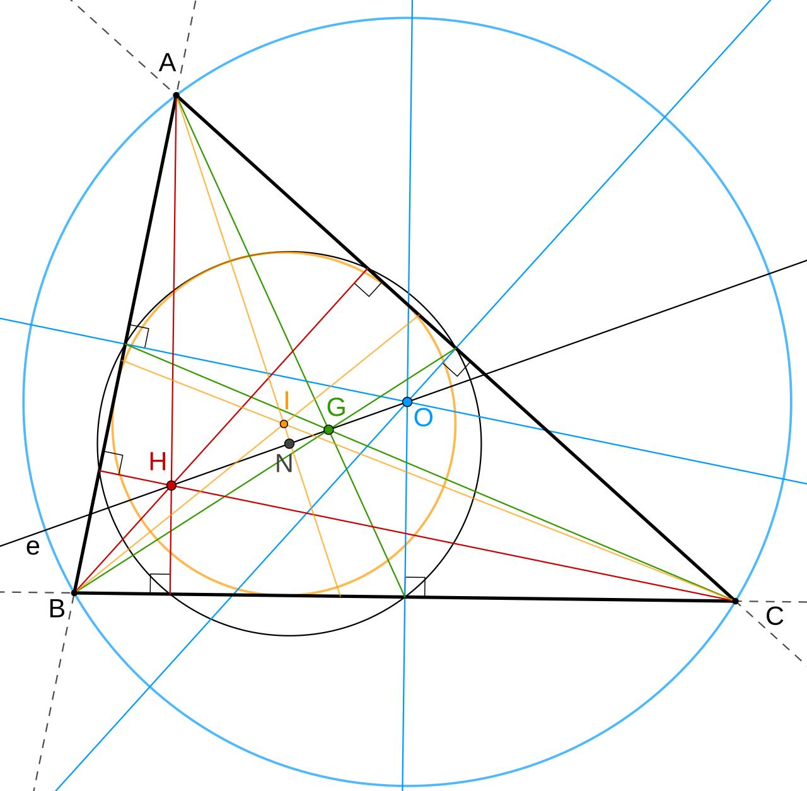
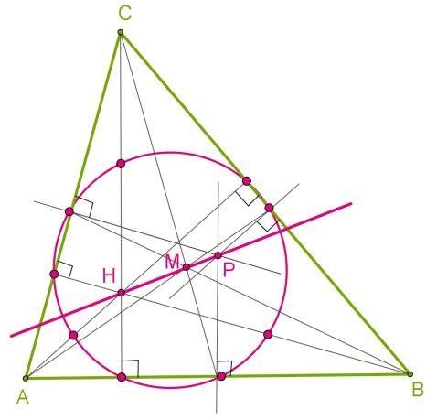
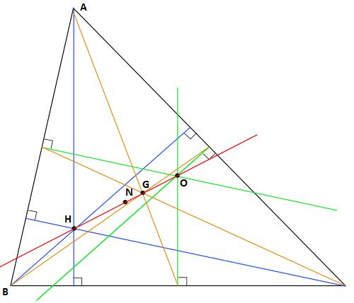

Euler Line and the Incenter
# Source: AI Source: Provided by: [Data Path: Persons Table -> ID Column: 1, Name_En Column: Motasem Essam] -> From: [ChatGPT] on [7/25/2026]
It is important not to assume that all triangle centers lie on the Euler line.
For a general triangle:
$$\boxed{O,G,H\text{ are collinear}}$$
but:
$$\boxed{I\text{ generally does not lie on the Euler line}}$$
The incenter lies on the Euler line only in special symmetric cases, such as an equilateral triangle.

Euler Line and the Nine-Point Center
# Source: AI Source: Provided by: [Data Path: Persons Table -> ID Column: 1, Name_En Column: Motasem Essam] -> From: [ChatGPT] on [7/25/2026]
Another important triangle center is the Nine-Point Center, usually denoted by $N$.
For a general triangle, the nine-point center also lies on the Euler line.
Thus:
$$\boxed{O, N, G, H}$$
are collinear.
The nine-point center lies halfway between the circumcenter and orthocenter:
$$\boxed{ON=NH}$$
and therefore:
$$\boxed{ON=NH=\frac{1}{2}OH}$$
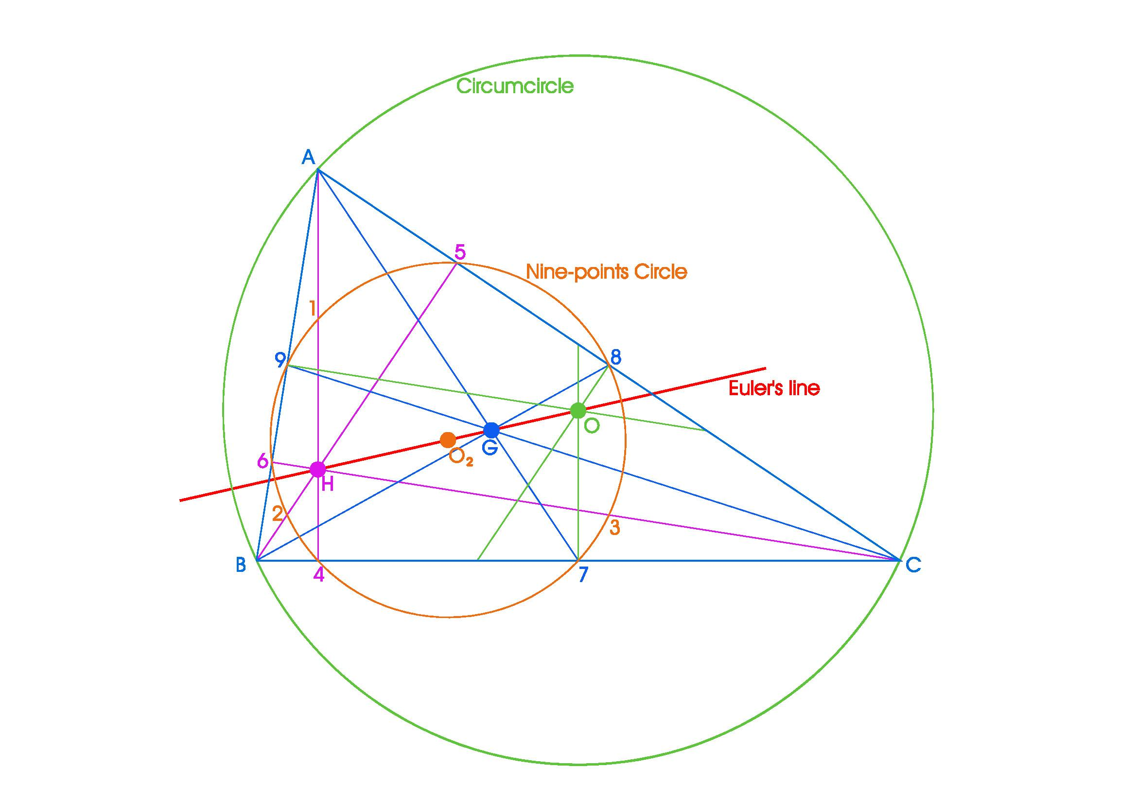
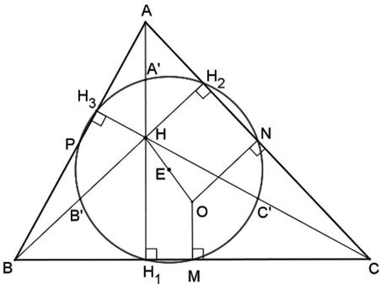

Relative Order of the Centers
# Source: AI Source: Provided by: [Data Path: Persons Table -> ID Column: 1, Name_En Column: Motasem Essam] -> From: [ChatGPT] on [7/25/2026]
For many non-equilateral triangles, the centers can be represented along the Euler line as:
$$\boxed{O - N - G - H}$$
where:
- $O$= circumcenter
- $N$= nine-point center
- $G$= centroid
- $H$= orthocenter
However, the exact geometric appearance depends on the triangle, and the important invariant relationships are:
$$\boxed{OG:GH=1:2}$$
and:
$$\boxed{ON=NH}$$

Euler Line in an Acute Triangle
# Source: AI Source: Provided by: [Data Path: Persons Table -> ID Column: 1, Name_En Column: Motasem Essam] -> From: [ChatGPT] on [7/25/2026]
In an acute triangle, both the circumcenter and orthocenter lie inside the triangle.
The Euler line therefore passes through three interior points:
$$O, G, H$$
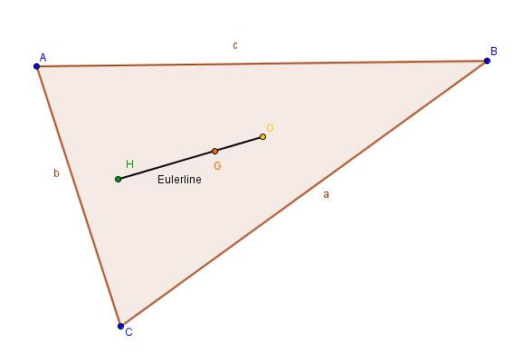
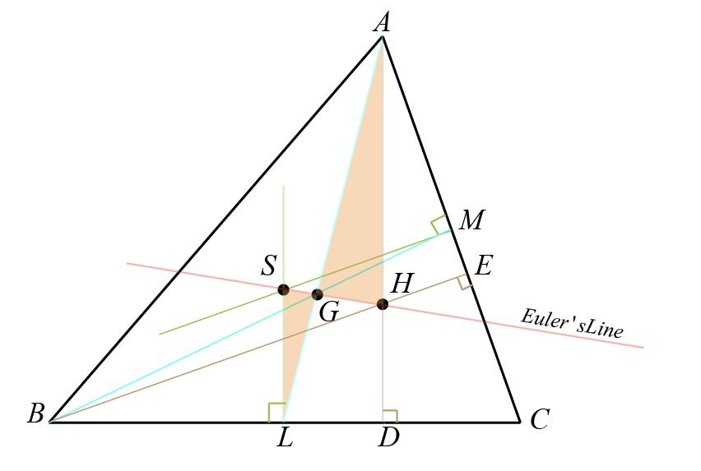

Euler Line in a Right Triangle
# Source: AI Source: Provided by: [Data Path: Persons Table -> ID Column: 1, Name_En Column: Motasem Essam] -> From: [ChatGPT] on [7/25/2026]
For a right triangle:
- $H$is the right-angle vertex.
- $O$is the midpoint of the hypotenuse.
- $G$is the centroid.
All three still lie on the Euler line.
For example, consider:
$$A=\left(0 , 0\right) \\ B=\left(6 , 0\right) \\ C=\left(0 , 8\right)$$
The orthocenter is:
$$H=\left(0 , 0\right)$$
The circumcenter is:
$$O=\left(3 , 4\right)$$
The centroid is:
$$G=\left(\frac{0+6+0}{3} , \frac{0+0+8}{3}\right) \\ G=\left(2 , \frac{8}{3}\right)$$
These three points are collinear.

Euler Line in an Obtuse Triangle
# Source: AI Source: Provided by: [Data Path: Persons Table -> ID Column: 1, Name_En Column: Motasem Essam] -> From: [ChatGPT] on [7/25/2026]
In an obtuse triangle, the circumcenter and orthocenter may lie outside the triangle.
Nevertheless:
$$\boxed{O, G, H\text{ remain collinear}}$$
The Euler-line theorem therefore applies regardless of whether the triangle is acute, right, or obtuse, provided the triangle is nondegenerate.

Euler Line vs Triangle Center
# Source: AI Source: Provided by: [Data Path: Persons Table -> ID Column: 1, Name_En Column: Motasem Essam] -> From: [ChatGPT] on [7/25/2026]
The Euler line is not itself a triangle center.
Instead:
$$\boxed{\text{Triangle Centers}→\text{Points}}$$
while:
$$\boxed{\text{Euler Line}→\text{Line containing important centers}}$$
For example:
- $G$is a point.
- $O$is a point.
- $H$is a point.
- The Euler line is the line containing them.

Euler Line vs Median
# Source: AI Source: Provided by: [Data Path: Persons Table -> ID Column: 1, Name_En Column: Motasem Essam] -> From: [ChatGPT] on [7/25/2026]
A median is a segment:
$$\overset{‾}{AD}$$
where $D$is the midpoint of $BC$.
The Euler line is a line determined by triangle centers.
They are therefore different concepts.
However, the centroid $G$, which lies on every median, also lies on the Euler line.

Important Properties
# Source: AI Source: Provided by: [Data Path: Persons Table -> ID Column: 1, Name_En Column: Motasem Essam] -> From: [ChatGPT] on [7/25/2026]
- The Euler line contains the:
$$\boxed{O, G, H}$$
- $O$is the circumcenter.
- $G$is the centroid.
- $H$is the orthocenter.
- For a non-equilateral triangle:
$$\boxed{OG:GH=1:2}$$
- Therefore:
$$\boxed{OH=3OG}$$
- The nine-point center $N$also lies on the Euler line.
- The incenter $I$generally does not lie on the Euler line.
- In an isosceles triangle, the Euler line is the axis of symmetry.
- In an equilateral triangle:
$$\boxed{O=G=H=I}$$

Classification
# Source: AI Source: Provided by: [Data Path: Persons Table -> ID Column: 1, Name_En Column: Motasem Essam] -> From: [ChatGPT] on [7/25/2026]
For your geometry knowledge-base hierarchy, I recommend:
Plane Geometry
└── Triangles
├── Triangle Centers
│ ├── Triangle Centroid
│ ├── Triangle Incenter
│ ├── Triangle Circumcenter
│ ├── Triangle Orthocenter
│ └── Nine-Point Center
│
└── Triangle Center Relationships
└── Euler Line
Alternatively, if you want the Euler Line directly connected to the centers:
Plane Geometry
└── Triangles
└── Triangle Centers
├── Triangle Centroid
├── Triangle Incenter
├── Triangle Circumcenter
├── Triangle Orthocenter
└── Triangle Center Relationships
└── Euler Line
I recommend the second structure if your knowledge base treats relationships among triangle centers as part of the Triangle Centers topic.

Related Concepts
# Source: AI Source: Provided by: [Data Path: Persons Table -> ID Column: 1, Name_En Column: Motasem Essam] -> From: [ChatGPT] on [7/25/2026]
The Euler Line is directly related to:
- Triangle Centroid
- Triangle Circumcenter
- Triangle Orthocenter
- Nine-Point Center
- Medians
- Altitudes
- Perpendicular Bisectors
- Circumcircle
- Nine-Point Circle
- Euler's Theorem
- Triangle Centers

Key Formula Summary
# Source: AI Source: Provided by: [Data Path: Persons Table -> ID Column: 1, Name_En Column: Motasem Essam] -> From: [ChatGPT] on [7/25/2026]
Collinearity
$$\boxed{O, G, H\text{ are collinear}}$$
Centroid ratio
$$\boxed{OG:GH=1:2}$$
Circumcenter–orthocenter distance
$$\boxed{OH=3OG}$$
Orthocenter from centroid and circumcenter
$$\boxed{H=3G-2O}$$
Nine-point center
$$\boxed{ON=NH=\frac{1}{2}OH}$$
Equilateral triangle
$$\boxed{O=G=H=I}$$

Conclusion
# Source: AI Source: Provided by: [Data Path: Persons Table -> ID Column: 1, Name_En Column: Motasem Essam] -> From: [ChatGPT] on [7/25/2026]
The Euler Line is a fundamental line in triangle geometry that connects several important triangle centers. For a non-equilateral triangle, the circumcenter $O$, centroid $G$, and orthocenter $H$are always collinear:
$$\boxed{O, G, H\text{ are collinear}}$$
The centroid divides the circumcenter–orthocenter segment according to:
$$\boxed{OG:GH=1:2}$$
The nine-point center also lies on this line, making the Euler line one of the most important structural relationships among triangle centers.

